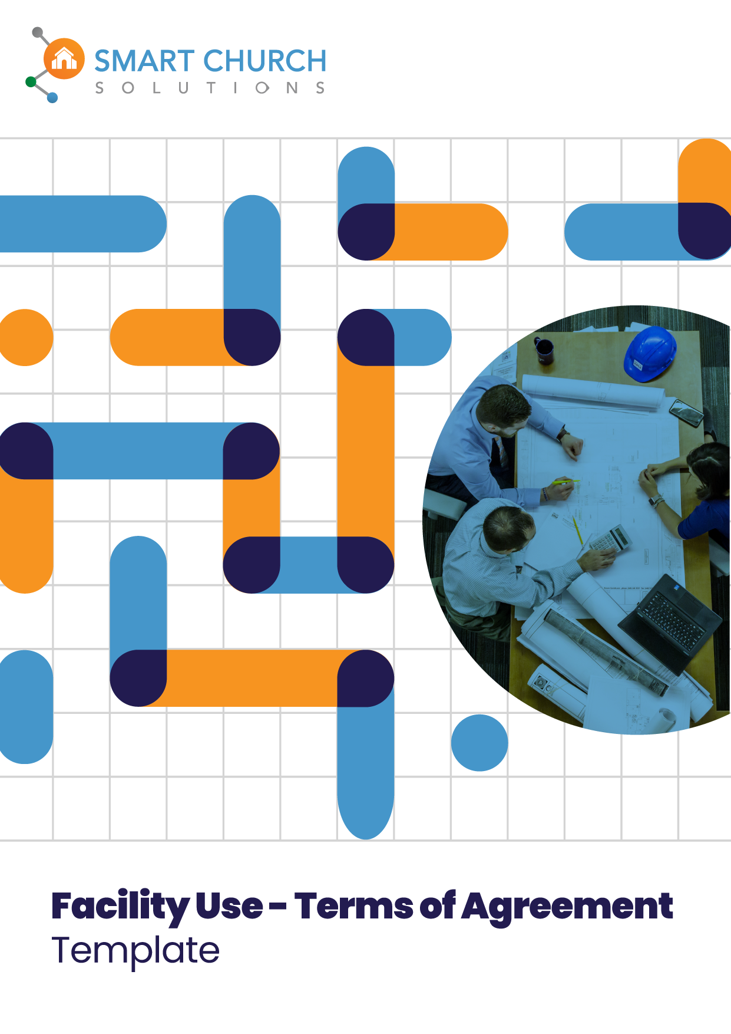

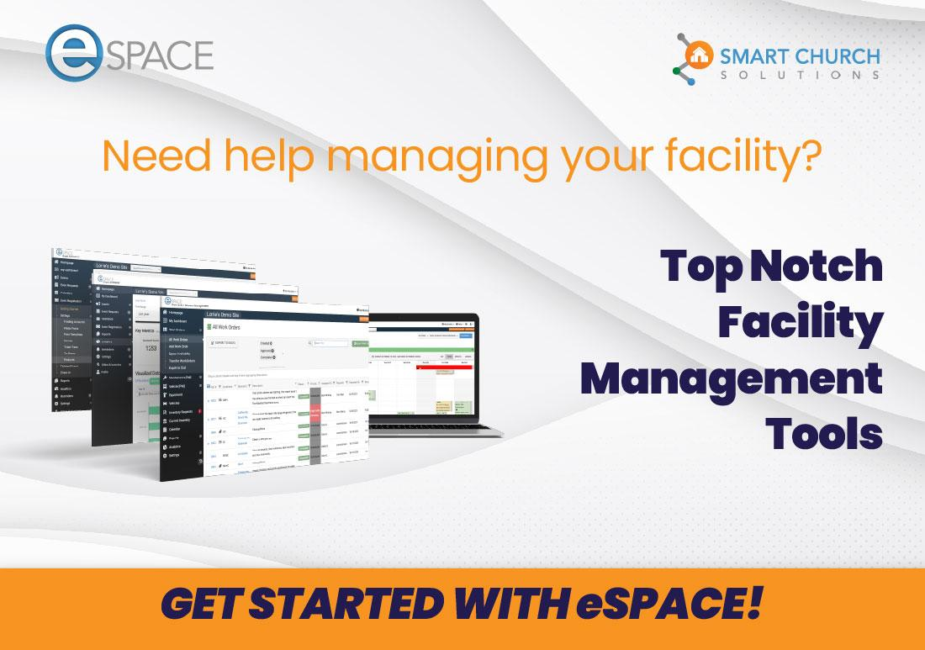

(Keep Scrolling to Template)

↓↓↓↓↓
[Your Church Name Here] Facility Use Terms of Agreement - DRAFT

DISCLAIMER: This sample Facility Use Agreement, provided by Smart Church Solutions, is a general template, not legal advice. It is essential to consult a qualified attorney to customize it for your specific needs and ensure compliance with local laws. Smart Church Solutions is not liable for any issues arising from its use and makes no warranties or representations regarding its suitability. Laws vary by jurisdiction, so you must verify compliance with relevant regulations. Using this template, you agree to these terms and acknowledge that it does not establish an attorney-client relationship. Additionally, we recommend that your leadership consider your organization's statement of beliefs, policies, theology, etc., and incorporate them as deemed appropriate. Furthermore, as each organization may have different expectations regarding food and beverages for outside events, we suggest you clearly define your expectations and allowances in this document.

5 Helpful Things To Remember When Completing a Facility Use Terms of Agreement for [Your Church Name Here]

1. Request the Agreement: Please go to [Insert Link to your Facility Use Terms of Agreement Document Here] for a copy of the Facility Use Terms of Agreement.

2. Review and Understand: Read through the agreement carefully, paying attention to guidelines and responsibilities.

3. Fill in Event Details: Complete sections about your event, including name, date, time, and nature.

4. Sign and Submit: Sign and date the agreement, then return it to [Insert Church Contact Name and Email Information Here].

5. Stay Informed: Keep in touch with [Insert Appropriate Church Contact Information Here] for any updates or changes related to your event.

Introduction:

We sincerely thank you for considering [Your Church Name Here] as the venue for your upcoming event or activity. It is our privilege to host you, and we are committed to ensuring that your experience within our sacred space is both meaningful and respectful. To that end, we kindly ask that you carefully review and adhere to the following Terms of Use Agreement.

This agreement serves as a cornerstone of mutual understanding between [Your Church Name Here] and those utilizing our facilities. It is designed to foster an atmosphere of mutual respect and collaboration. By familiarizing yourself with these guidelines, you become an integral part of our collective effort to maintain the integrity of our facility while supporting you and your event.

1. Statement of Faith:
We at [Insert Church Name Here] hold to a statement of faith. Please read and familiarize yourself with that statement here: [Insert Link to Your Church’s Statement of Faith Here]. To approve your use of our facility, we require your group/event to be in agreement with our statement of faith.

2. Respectful Conduct:
We hold dear the values of respect and consideration for all individuals who enter our doors. We request that all attendees, organizers, and participants in your event uphold these principles, treating fellow guests, staff, and volunteers with kindness and courtesy.

3. Use of Facilities:
While you are here, we encourage you to utilize our facilities responsibly. Please take care to leave spaces in the same condition as you found them and remain within the designated spaces for your event. Any potential damages or concerns should be promptly reported to [Insert Appropriate Church Contact Information Here].*

*(If applicable) We contract parking through [Insert Parking Service Name Here] services, and there is a nominal fee. After you submit your event, a parking cost will be determined based on the event's size, time, and duration. Once determined, the fees will be added to the event total.

4. Noise Levels:
In consideration of others, please be mindful of noise levels during your event.

5. Decorations and Set-Up:
Feel free to enhance the ambiance of your event with decorations, provided they are respectful of maintaining the integrity of the space. Any decorations or similar that are to be attached to walls, ceilings, columns, doors, etc., must have prior written permission from the church's facility staff. All decorations must be discussed and approved prior to the event. No church-owned property may be removed without prior consent. Any methods of attachment to any surfaces must be per our facility use policy.

6. Security and Safety:
Our guests' safety and well-being are paramount. We request your cooperation in adhering to any safety instructions provided by our staff or posted signage. All activities will be required to comply with the church safety and security policy. Any activities involving minors (where parents or legal guardians are absent) will require all adult volunteers to have a background screening. The requesting organization must provide a statement to the church affirming their compliance to receive approval.*

*(If applicable) We require security for any event held on our campus. The size, duration, and type of event will determine the overall security need. Once submitted, our security director will assess the additional cost for minimal coverage.

7. Clean-Up:
Following the conclusion of your event, we kindly ask that you ensure all areas used are left clean and orderly. Trash should be disposed of appropriately in the dumpster (or designated area), and any items brought in should be removed. Any items left behind after the event will be discarded.

Cleaning Fee: _______________

8. Compliance with Laws and Regulations:
All federal, state, and local laws must be followed during your time at [Your Church Name Here]. This includes any necessary permits or licenses for your event.

Utilizing our facilities signifies your agreement to these terms and conditions. We are grateful for your cooperation and look forward to providing a welcoming and supportive environment for your event. Should you have any questions or require further assistance, please do not hesitate to contact us at [Insert Appropriate Church Contact Information Here]. Thank you for choosing [Your Church Name Here].

Date of Agreement:__________________________

Facility User Information:
Name of Organization/Individual:__________________________
Contact Person:__________________________
Address:__________________________
Phone:__________________________
Email:__________________________

Event Details:
Event Name: __________________________
Date(s) of Event:__________________________
Time(s) of Event:__________________________
Expected Number of Participants:__________________________
Do you require AVL usage for your event?* [ ] Yes [ ] No

*If yes, there is a minimum 2-hour charge for every church-qualified and trained AVL operator required, along with a 2-hour minimum fee. Any slides or videos must be provided no later than the day before the event for proper setup. Only church-qualified AVL operators are allowed to operate the permanently installed equipment. If you only need access to a portable TV with a DVD player, that does not require a technician. After your event is submitted, the appropriate fee will be determined and provided to you, along with the contact details of your primary technician.

Facility Request:
Preferred Facility/Room:__________________________
Alternative Facility/Room:__________________________ (in case the preferred one is unavailable)
Setup Requirements:__________________________ (e.g., tables, chairs, audio/visual equipment, etc.)
Will Food/Refreshments be Served? [ ] Yes [ ] No
Other Special Requirements:
____________________________________________________________________________________________________________________________________

Purpose of Event:
Please provide a brief description of the event's purpose and activities:
________________________________________________________________________________________________________________________________________________________________________________________________________________________________________________________________________

Additional Notes/Comments:
________________________________________________________________________________________________________________________________________________________________________________________________________________________________________________________________________

By signing below, the Facility User acknowledges and agrees to abide by the terms and conditions of this agreement.

Signature of Facility User: __________________________ Date:____________

[Your Church Name Here] Representative: __________________________ Date: ____________

Approval Status: [ ] Approved [ ] Denied [ ] Pending

This agreement constitutes the entire understanding between the parties and supersedes all prior agreements, oral or written. Any modifications to this agreement must be made in writing and signed by both parties.

